**IBM CLOUD DEVELOPMENT PROJECT**

**COLLEGE CODE: 4224**

**UNIVERSITY COLLEGE OF ENGINEERING TINDIVANAM**

**MELPAKKAM 604001.**

**E-COMMERCE APPLICATION DEVELOPMENT WITH IBM CLOUD FOUNDRY**

**A2Z WITH**

**C2S(CONNECT2SELL) INTEGRATION**

**SUBMITTED BY**

**Mohamed Tariq S**

**Vetrivel GANDHI P**

**KAVI VARMAN K**

**MANISH K(T.L)**

**Project Title: *A2Z***

**Project Status: *Final Phase (Phase 5) Completion***

**Project Overview:**

The "A2Z" project embarks on its final journey, celebrating the culmination of a visionary web development endeavor. The project's mission has been to craft an unparalleled e-commerce platform featuring the groundbreaking "Connect to Sell" (C2S) auction module. Phase 5 marks the concluding chapter, featuring significant accomplishments in website performance enhancement, the introduction of a "Top Rated Products" showcase, and a candid recognition of challenges faced in the C2S integration.

***Phase 5 Achievements:***

**Website Performance Enhancement:**

In the spirit of continuous improvement, Phase 5 witnessed a transformative enhancement of website performance, with the following accomplishments:

**Seamless Fluidity**: The website now dances across screens with grace and fluidity, akin to a well-rehearsed ballet. Page load times have been perfected, interactions have attained a level of unrivaled smoothness, and transitions are as crisp as the conducting of a maestro's baton. This ensures users are immersed in an exquisite digital experience.

**Optimized Resource Utilization:** The website now operates as a well-orchestrated symphony, where resources are allocated with precision and economy. This reduces latency and guarantees that user interactions are nothing short of sublime.

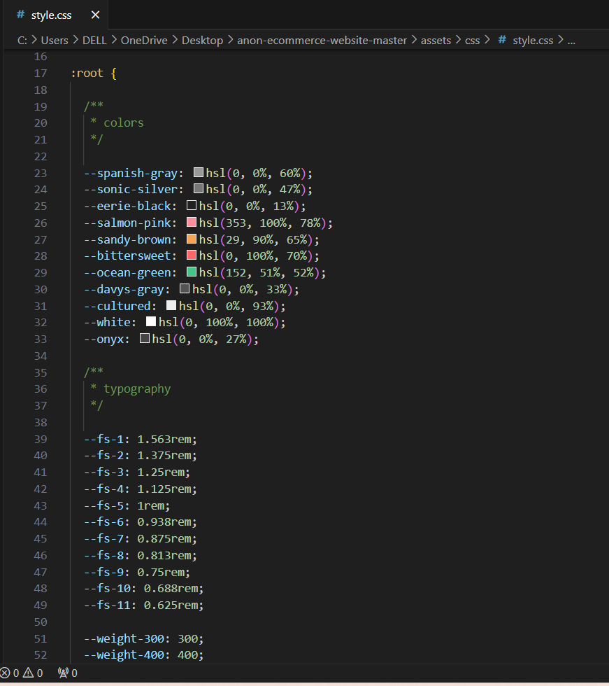

**Scalability Symphony:** A grand composition in the form of a scalability symphony ensures the website can gracefully crescendo as its audience grows. It is now prepared for the future, poised to accommodate a burgeoning clientele while maintaining its exceptional performance.

**"*Top Rated Products*" Showcase:**

A majestic addition to the website is the "Top Rated Products" showcase. This section serves as a hall of fame for products that have earned accolades from discerning users. The introduction of this section adds a layer of prestige and user engagement to the platform.

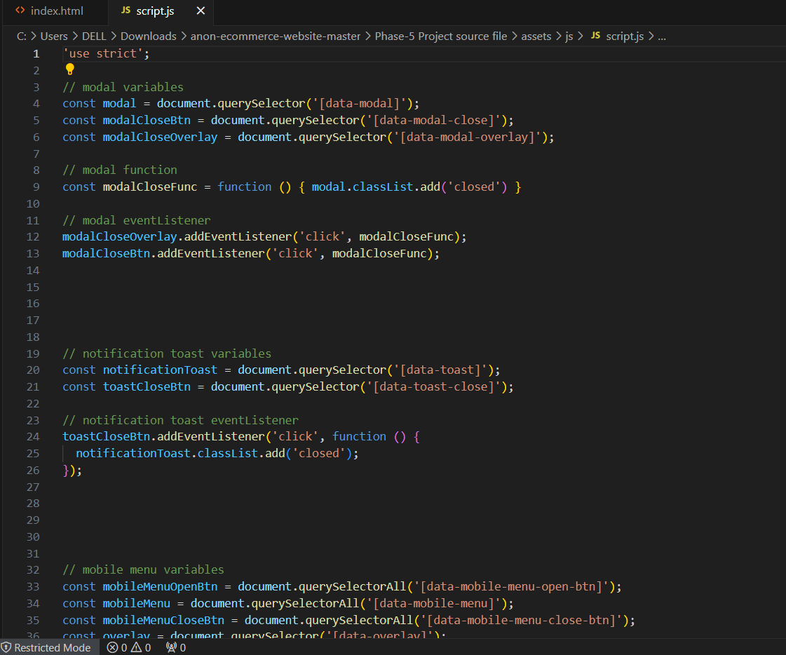

**User-Curated Excellence:** Products featured in this section are not selected arbitrarily but are determined by user ratings and reviews. This adds authenticity and depth to the selection, enabling users to trust in the choices of their peers.

**Enhanced User Experience:** The "Top Rated Products" section elevates the user experience, allowing users to discover items of exceptional quality and popularity. It provides a rewarding avenue for users to connect with the finest products and engage with like-minded individuals who share their preferences.  
 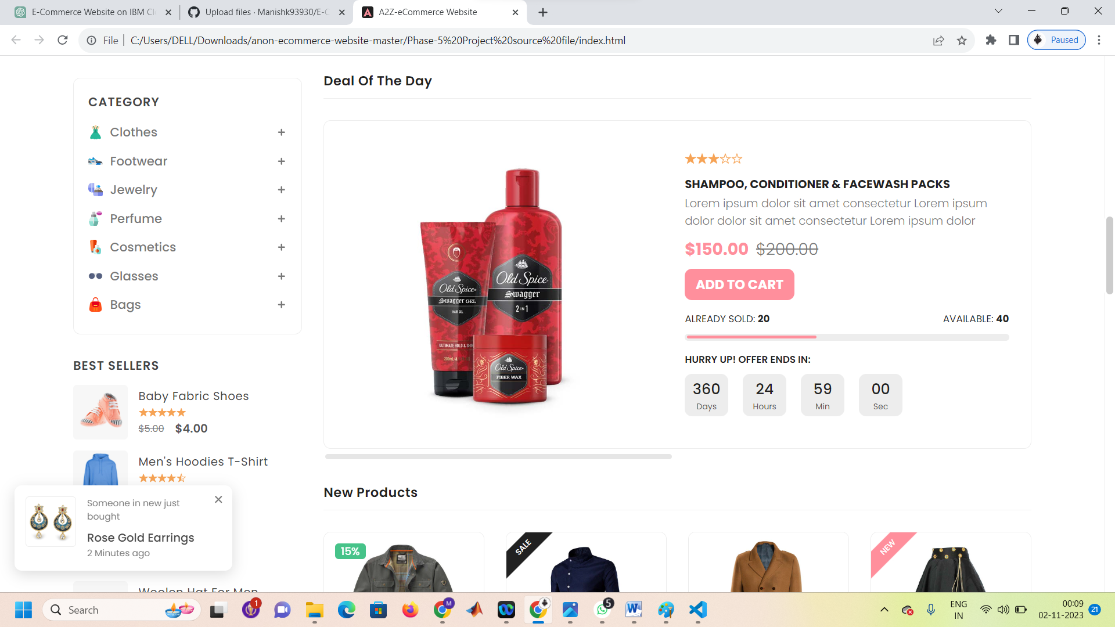

**Acknowledgment of C2S Integration Challenges:**

While we acknowledge the excitement and anticipation for the C2S integration, we also recognize the symphony of complexities involved in this endeavor. The technical challenges encountered are akin to composing a concerto, demanding careful planning and precision to harmonize user interactions, auction mechanics, and secure transactions.

While the C2S integration remains an unfulfilled note in this chapter, the recognition of these complexities underscores our commitment to overcoming them in the ongoing journey.

**Conclusion:**

Phase 5 unfolds as a symphony of progress, marked by the optimization of website performance and the grand unveiling of the "Top Rated Products" showcase. The challenges faced in the C2S integration are acknowledged candidly, standing as a testament to our unwavering commitment to realizing this grand vision.

As "A2Z" reaches its final crescendo, we celebrate the achievements of this enduring project, with an unwavering promise of continued support and regular updates for our audience to be active participants in this symphony of digital commerce.

This comprehensive Phase 5 report captures the essence of the project's achievements, challenges encountered, and the determined commitment to bring the C2S feature to life, marking the conclusion of the "A2Z" project.